**Angeles  City Science High School**

**MAPEH 9**

**Name:** Paul Gerald D. Pare **Section:** 9 - Adenine

## Drug Scenario

## 

## Let Us Remember (Tandaan Mo)

**ACTIVITY NO. 2**

Summarize the ideas. Write your corresponding answer in a separate paper

What are the most common abuse substances in the Philippines?

Shabu, Marijuana and Inhalants

What is RA 9165 all about?

R.A 9165 “ Comprehensive Dangerous Drugs Act of 2002

What are the common terms related to drugs?

Drug tolerance, drug abuse, drug of abuse, drug misuse, drug dependence

What is drug?

A drug is any substance that causes a change in an organism's physiology or psychology when consumed.

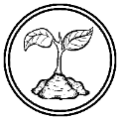

**ACTIVITY NO. 3**

Analyse the situation given and choose which is applicable from the common concept in drug education you have learned. Then justify or explain your answer on a sheet of paper

* 1. Rolando used a certain substance not for medication or illness in the body but for certain pleasure. Drug Abuse

Explanation: Misleading or incorrect usage of a medical drugs is considered drug abuse.

* 1. Everyday, you observe Benjo who is one of the street children that asked for alms, holding a small plastic and straw hidden inside his shirt and inhaling it every now and then. Drug Abuse

Explanation: It is considered drug abuse if it is used not properly/incorrectly.

* 1. Jessa use substance inconsistent with the prescribed dosage of the doctor. Drug Misuse

Explanation: This one is considered a drug misuse because she use the drugs for the right purpose but she take it incorrectly.

* 1. Bob tried to use cigarettes in his teenage life, and then later on he tried the marijuana. Now, his body is not satisfied with the effects of those substances requiring larger amounts or dosage. Drug Tolerance

Explanation: He can’t tolerate the effects of drugs thus this is a drug tolerance.

* 1. Julia cannot sleep without taking the pills in the night. Drug Dependance

Explanation: Without her sleeping pills, she can’t sleep and she depends on a drug.

**The Risk and Protective Factor**

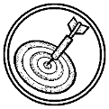

## Let Us Practice (Pagsanayan Mo)

**Activity 1**

Match the risk factors that may influence drug use with the appropriate protective factors. Choose the correct answer from the table below and write it on a piece of paper.

|  |  |
| --- | --- |
| Positive attitude which combat drug use | Sense of belongingness |
| Excellent social skills | Strong family values |
| Clear and consistent family rules | Shows interest in attending class |
| Excellent academic performance | High self-respect and self-esteem |

Risk Factors Protective Factors

1. Feelings of Isolation Sense of belongingness
2. Poor social skills and interactions Excellent Social Skills
3. Poor family values Strong family values
4. Inconsistent family rules Clear and consistent family rules
5. Poor academic performance Excellent academic performance
6. Poor attendance in class Shows interest in attending class
7. Negative attitude which favor drugs Positive attitude which combat drug usen
8. Lack of self-respect and self-esteem High self-respect and self-esteem

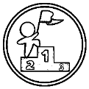**LET US PRACTICE MORE (GAWIN MO)**

## ACTIVITY NO. 4

Choose the role from the following diagram and do the task indicated. (Use short bond paper)

# “I want to be a writer!”

Drug abuse can result to mentally ill and various disease because of misuse of a drugs. Like any edible food, too much taking of drugs will lead to bad things such as Illness leading to death. Using a drugs besides the prescribe is a bad thing. It might not give immediate result, but it slowly turning into a bad result in the end. Using biogesic to treat fever is the right purpose, if you use it for treating diabetes it won’t work and it will give bad health effects to the patient.

## ACTIVITY NO. 2

In the Philippines, you have to be 18 years old to smoke and drink but most of the time, this does not happen. How would you advertise to show the proper age in smoking and drinking by drawing? Draw your output on a piece of short bond paper. Give your drawing a title and an explanation of your output. Rubric for the drawing:

|  |  |  |  |
| --- | --- | --- | --- |
| Student Expectation Points Self Teacher | | | |
| Drawing matches the description and topic | **15** |  |  |
| Drawing includes many details (shapes, colors, sizes, etc.) | **20** |  |  |
| Drawing is legible, and large enough to see all details | **20** |  |  |
| Drawing has a title that helps explain the content | **10** |  |  |
| Drawing has brief statements that explains what the  drawing is about | **15** |  |  |
| Drawing is submitted on time | **20** |  |  |

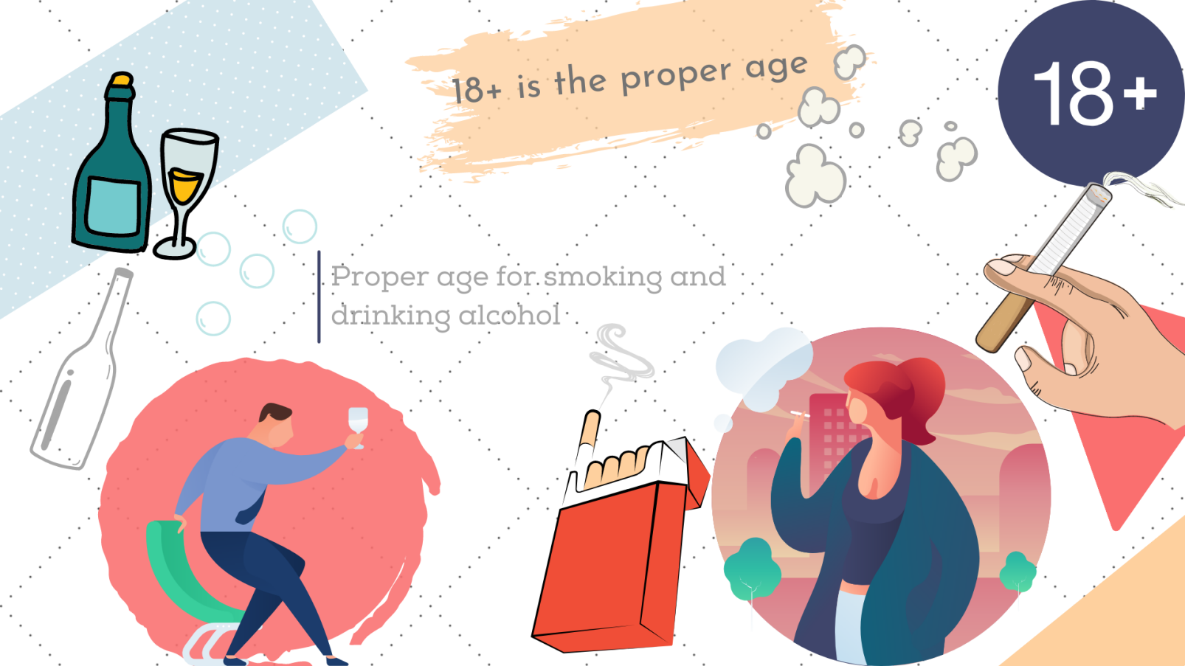

 **LET US APPRECIATE (ISAPUSO MO) ACTIVITY NO. 3**

Create a poster that shows the harmful effects of Abuse of Drugs in a person’s life. Make it creative and colorful. Write 3 sentences that explain the poster.

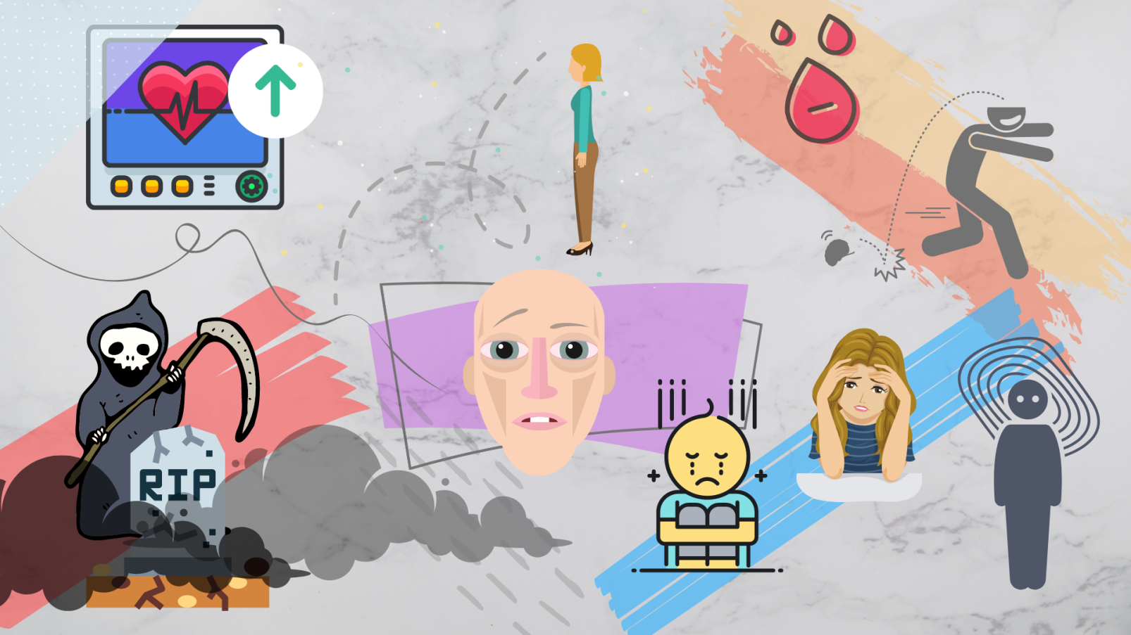

This poster shows the negative effects of drug abuse. Increases Heart Rate, Death if its too much, noticeable changes in appearance, anxiety, depression, poor academic performance, loss in weight. Some of them are in long term but some of them are short term.

ACTIVITY 4: ADVOCACY BROCHURE

Now that you have learned the myths and misconceptions of drug use and abuse, create an advocacy brochure about drug use and abuse. Have your teacher review and approve the advocacy brochure. Produce ten copies of the advocacy brochure and distribute it to friends. Let them sign on a piece of paper as a proof of receipt and post on account.

Submit the original brochure once you returned the Activity sheet.

